Pilatus PC12 EFS50 questions

1. Cold start timings and splash screens:
If you’re not busy during the start, could you video the startup from when the battery goes on to the point that the EFS displays are fully initialised. I’d like to get an idea of the exact timings of the different self tests.

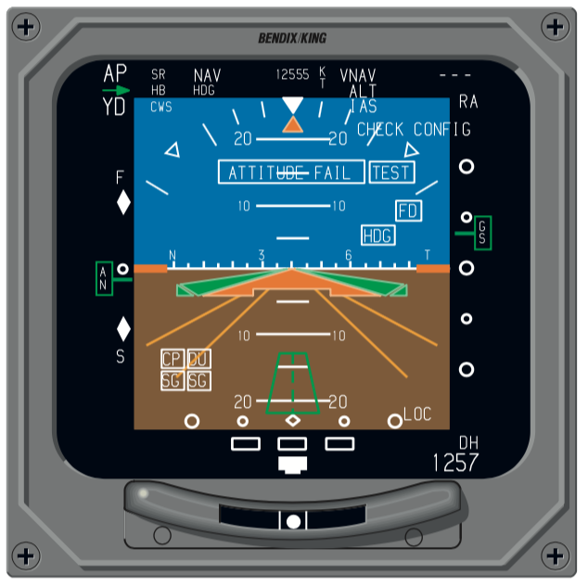
2. Does the EFS50 in the Pilatus have the orange perspective lines drawn at 30º and 45º of bank? This is an optional software selection upon certification.

3. Slow fast indicator comes in two options, does the PC12 have A, or B, or none?
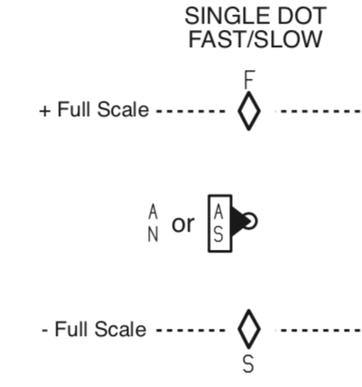  A | 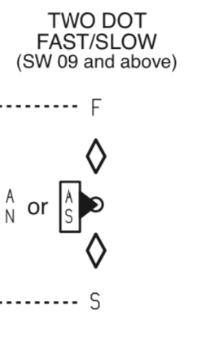  B

3. Text colour of YD text. I’m pretty sure it’s white however manual is not specific for YD
4. Vertical Pointer icon
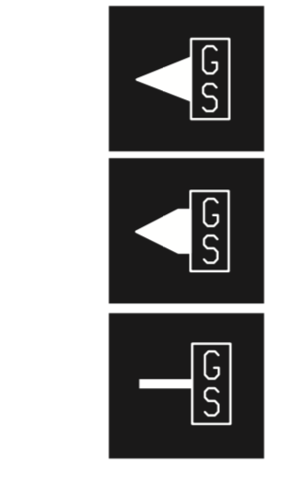
A
B
C

5. Is the heading tape on the AH always present or just in CMPST mode, if so does it have the HDG bug shown all the time?



